**LAB 3,ACS2, PANKAJ CHOUHAN**

**Problem 1, Part 2**

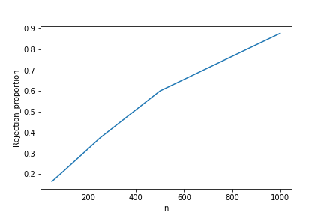

As the sample size increase we can see that Rejection Proportion approaches to 1.

### Problem 1, Part 3

Please refer to Notebook for theoretical explanation as it’s written in LATEX.

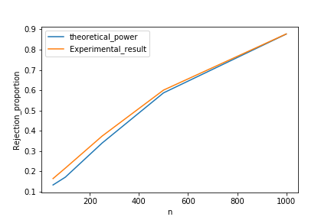

Theoretical Power is almost the same as what I have observed in experiment.

### Problem 2, Part 1

Please refer to Notebook for expression as it’s written in LATEX and I can’t copy them to WORD.

### Problem 2,Part 2

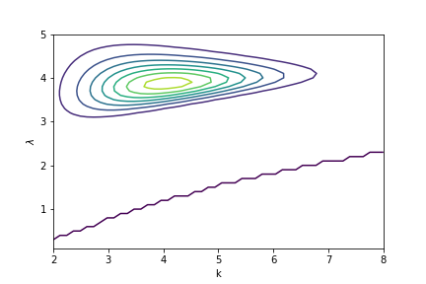

Note : - I am not aware of the reason for the line in plot. I tried to figure it out but can't seem to figure out a reason for this behavior.

### Problem 2, Part 3 and Part 4

**For X in range (3,6)**

**Results and Warning of the solver**

Warning: Desired error not necessarily achieved due to precision loss.

Current function value: -3.147914

Iterations: 3

Function evaluations: 98

Gradient evaluations: 86

k,lamb = 1.8247438778440916 4.242582359693068

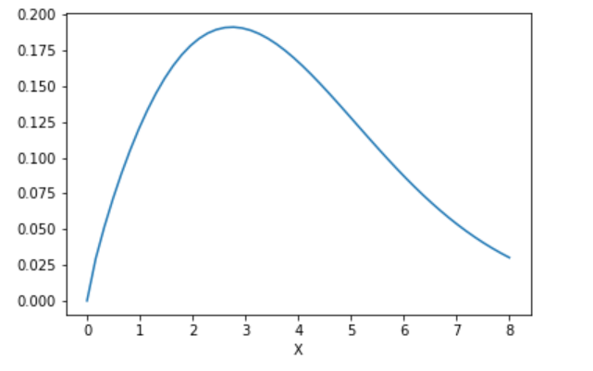

**For X in range (3,4)**

**Results and Warning of the solver**

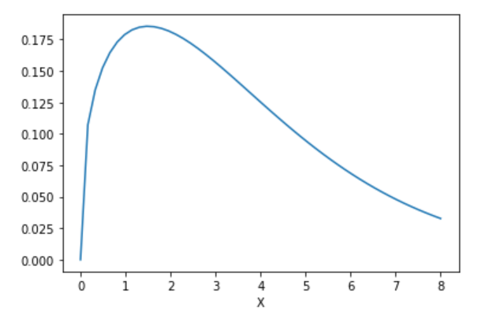

Warning: Desired error not necessarily achieved due to precision loss.

Current function value: -3.383666

Iterations: 3

Function evaluations: 100

Gradient evaluations: 88

k,lamb = 1.3616844114019195 3.9583389843755326

**For X in range (3,3.1)**

**Results and Warning of the solver**

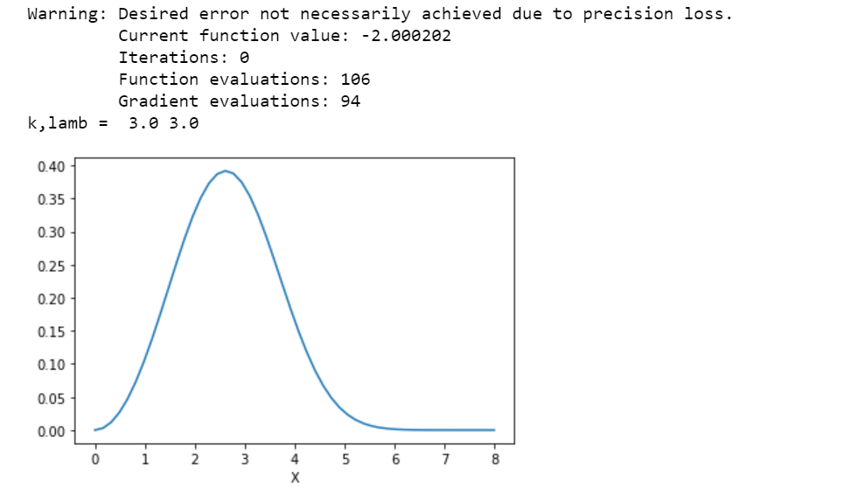

**I have used most of the solver available in scipy.optimize.minimize and none of them seems to able to minimize the problem. 'BFGS' solver come close to actual result, so therefore i am reporting the result from that solver.**